***_______________________PRAKTIKUM_QUEUE________________________***

**Nama : Muhamad Wahyu Saputra**

**Kelas : XII RPL B**

**Absen : 34**

**Modul 9**

**Apk Antrian**

**Desain Interface**

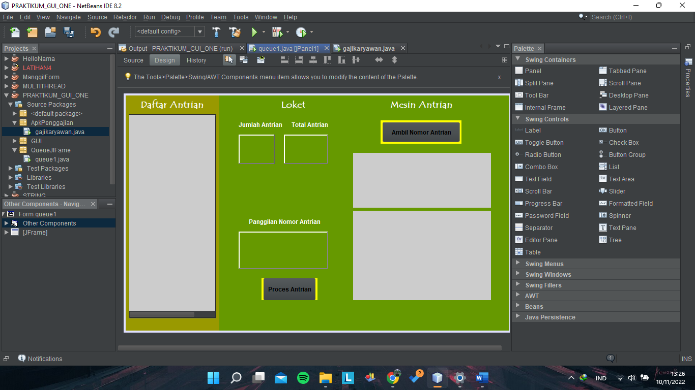

Hasil

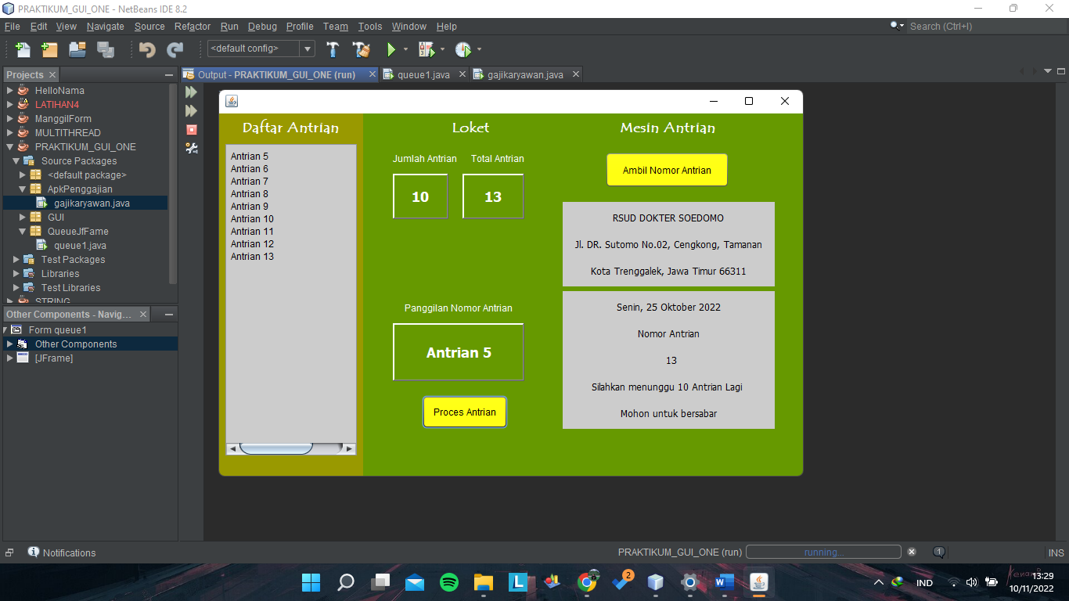

**Apk Penggajian**

**Desain Interface**

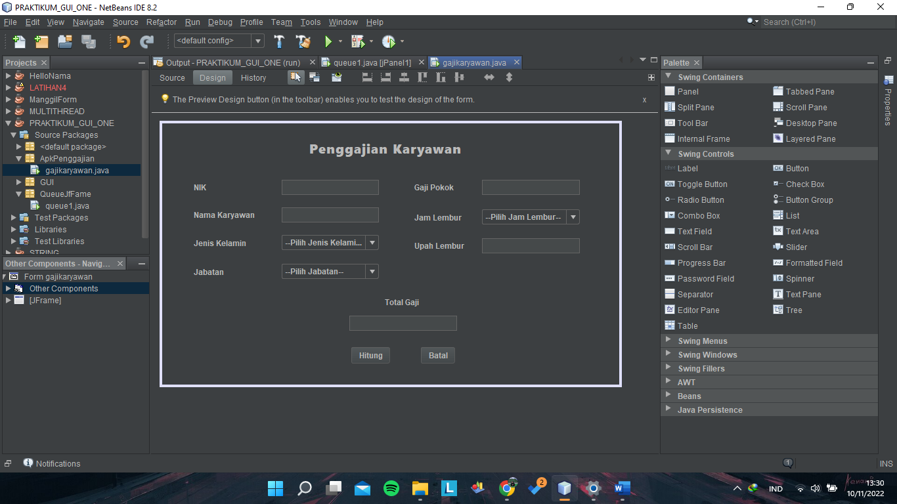

Hasil

